Harberton Village Walkabout

Harberton has always been predominantly agricultural, with a significant collection of farm houses in the centre of the village as well as in the surrounding area. Most of these are nowadays only residential and many of their barns have also been converted into housing. There are a number of more substantial residences in the parish, and most of these have also been converted and subdivided into smaller units. The centre of the village is the main square, in which St. Andrew’s Church and the Church House Inn can be found.
We start our tour in the church yard where we can find the Churchyard Cross (1). The base of this is probably mediaeval, but by the time photography arrived its top had long since disappeared, and the current cross was restored by Hems of Exeter, at the expense of Sir Robert Harvey in 1895.
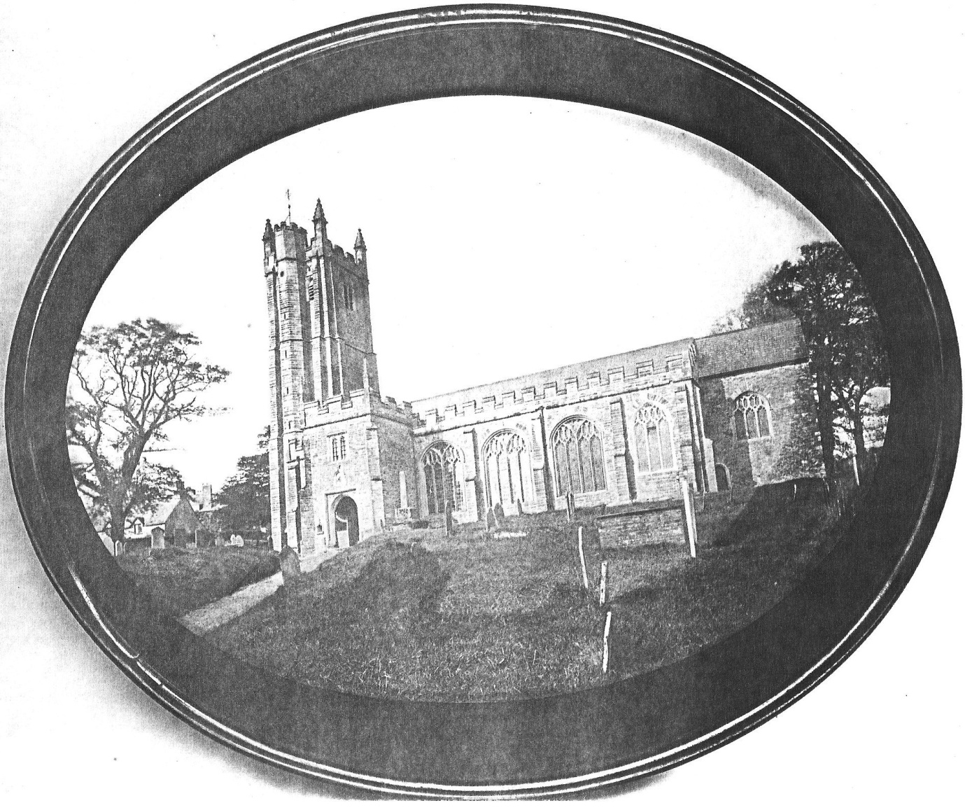
A view of the church around 1870 before all the external modernisation
Church Interior
When we step inside the church, one of the first things to notice is the old Norman Font (2), the oldest surviving item in the building. Presumably it was situated in the Norman church, which preceded the present building, for which we have no documentation or date. The earliest reference to a church in Harberton is a document noting the transfer of the revenues from the church to the diocese of Salisbury in 1122. The earliest reference to the building itself is a report of a visitation in 1302 to inspect the newly completed chancel, although we have a link to an early vicar named Benedict circa 1160.
The present Pews (3) were installed in the early 1860s and replaced an older set of pews which ran down the sides of the church rather than across it. These had been extended in 1826 under a grant from the Incorporated Church Building Society, which had been founded in 1818 to provide funds for the building and enlargement of Anglican churches throughout England and Wales.
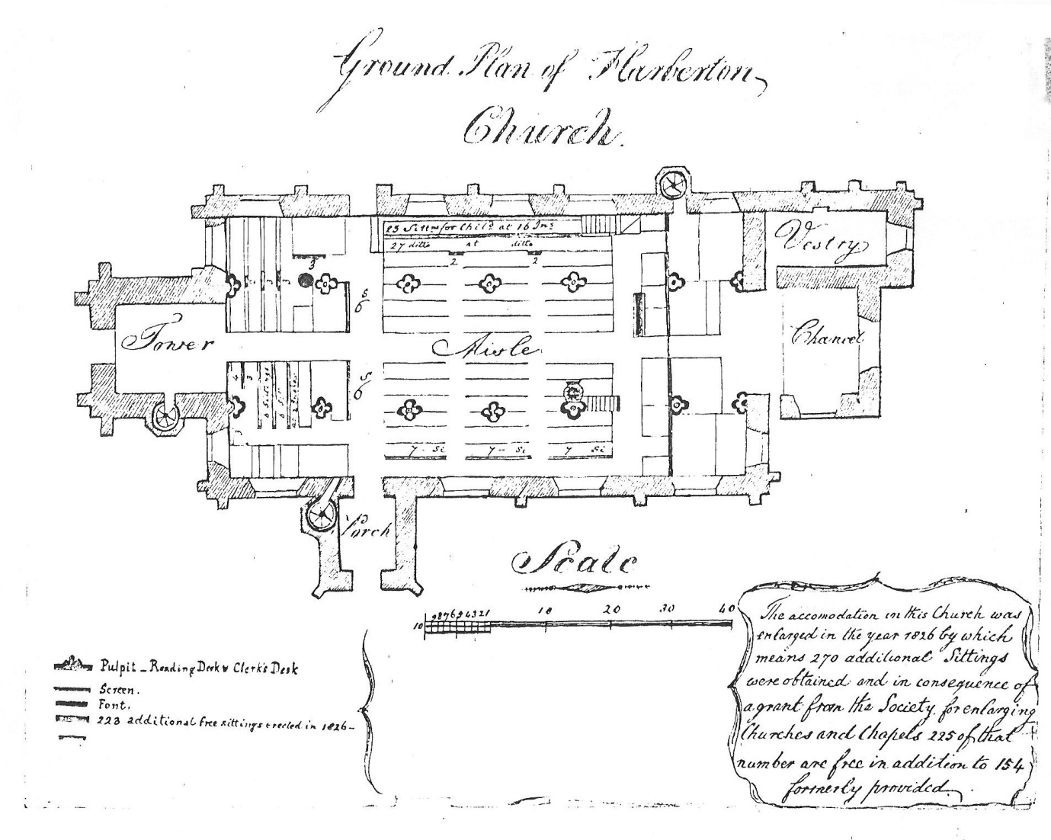
The church as it was after installation of new seating in 1826
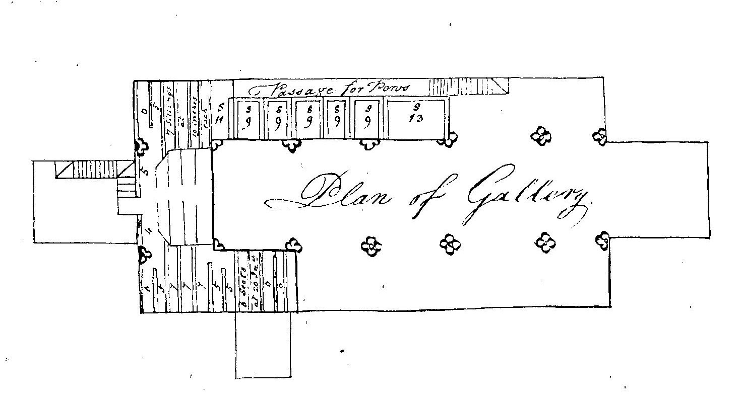
The layout of the gallery after the installation of new seating in 1826
At the front of the church we find a magnificent Screen (4) which was originally mediaeval but underwent significant Victorian restoration in 1870, at the expense of Mrs Wynne Pendarves of Tristford. Portions of the original screen can be seen in two cases at the rear of the church. The angels on the new screen are said to be based on the daughters of the Trist family.
The Pulpit (5) is also mediaeval but with later, possibly Flemish, figures of the apostles which replace those probably destroyed in the Reformation period.
The Father Willis Organ (6) was given by Mrs Thomasine Anthony in 1847, and was originally in the gallery at the rear of the church, but was restored and rebuilt in the north east corner of the church in 1891.
The Italian Marble effigy of Tito (7), was for Robert Godefroy ‘Tito’ Harvey, eldest son of Sir Robert Harvey, and was originally sited in the Harvey family vault in the churchyard in 1895. It was brought into the church in 1897, when it was already showing signs of deterioration.
The Windows (8) are mainly nineteenth century replacements commemorating the two major families in the village at the time, namely the Trists at Tristford House, and the Harveys at Dundrdge House.
Four bells were listed in the inventory of church goods in 1553. In 1762 a Peal of 6 Bells (9) were cast by Thomas Bilbie of Collumpton. In 1897 these bells were re-hung by Mr. Harry Stokes of Woodbury, and the 4th one re-cast by Messrs. Mears and Stainbank, London. An offer by Robert Harvey in 1917 to provide a full peal of 8 bells, to celebrate his 70th birthday, was rejected by the vicar who objected to the conditions attached to the offer, and instead these bells were accepted by Buckfast Abbey, in memory of Sir Robert’s wife. The bells were again re-hung in 1984.
The Clock (10) was given in 1897 by Robert Harvey to celebrate his 50th birthday. There was a stipulation that the clock should only have two faces on the south and west sides of the tower, so as not to be visible to anyone from the rival establishment at Tristford.
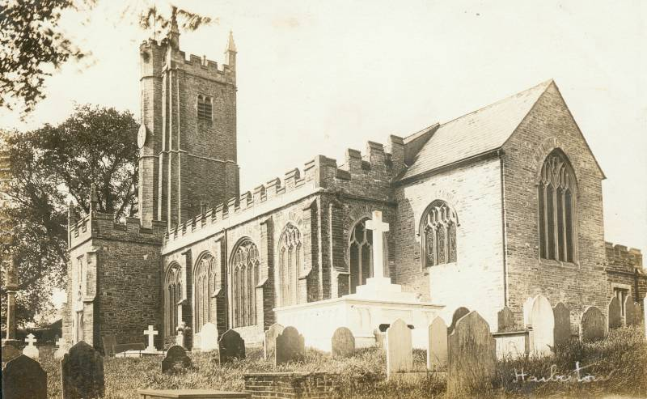
The Church after modernisation: note the Cross, the Clock, and the Harvey Tomb
Further details of all the sights in the church can be found on the boards provided for visitors, or in the visitors guide available at the rear of the church. We now leave the church and look at a few of the more interesting gravestones in the
Churchyard
On the lower southwest corner of the bell tower there is a nineteenth century Ordnance Survey Benchmark (11) showing a height of 79.2754 m (about 260 ft) above sea level.
Many of the gravestones in the churchyard were moved to the edges in 1977 in an attempt to make cutting the grass easier. Of interest are the Dunn (12) gravestone which records the deaths of Charles Henry Dunn, headmaster of the village school in Harberton from 1876 to 1889 before moving on to Halwell, and his wife Maria; the Farquharson (13) tomb which records the death of our Harberton V.C., Major F. E. H. Farquharson; the white marble Harvey tomb (14) which was constructed in 1895 as a family vault and contains three tombs each with a white marble recumbent figure on top, of Robert (Tito) Harvey, died 1895; Sir Robert Harvey, died 1930; and Alida Lady Harvey, died 1901; the Martin (15) tomb which records the (untimely) death of the Rev. George Martin who was Vicar of Harberton from 1820 to 1860; and the Varder tomb (16) which records the deaths of Ann and Stephen Varder, the parents of Mary Varder who left Harberton, Devon for Tierra del Fuego in 1871, and helped to establish Harberton, Tierra del Fuego in 1887. We now move down the church path and through the lych gate to the
Ford Farm area
Outside the Lych Gate at the bottom of the churchyard we can see a small building which is all that remains of a row of houses known as Church Terrace (17). These were condemned as unsuitable for habitation and demolished in the 1970s, and Lych Gate House was erected on the site. Immediately in front of the Lych Gate the stream which now goes under the road was once a Ford (18)
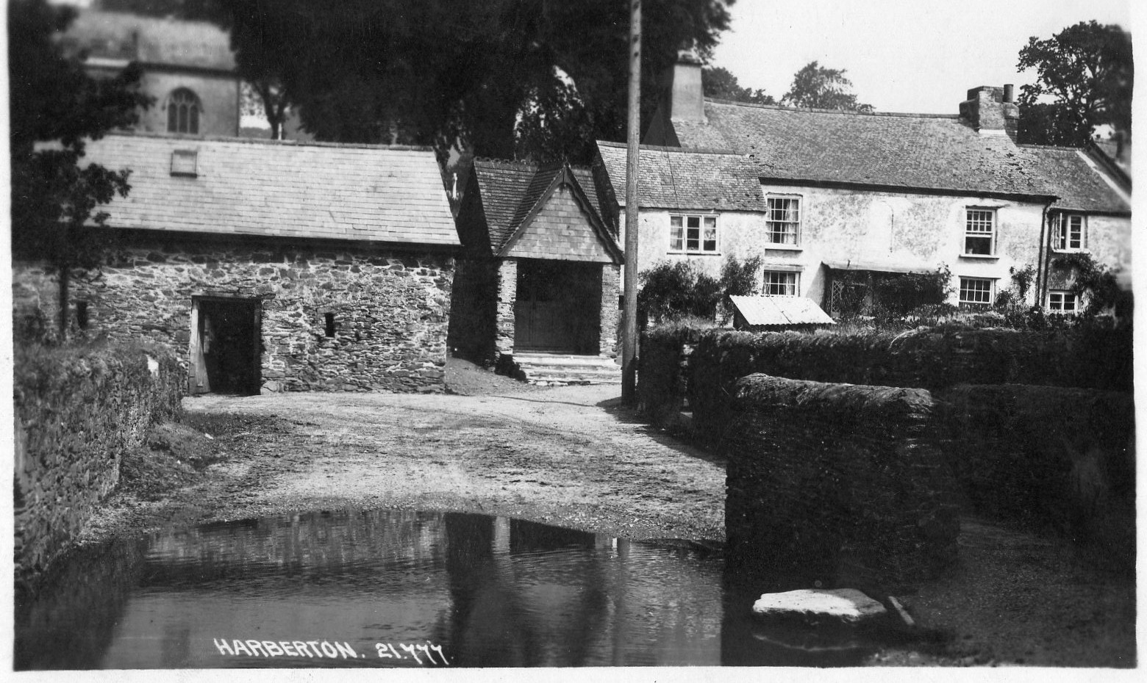
A view of the ford and Church Terrace
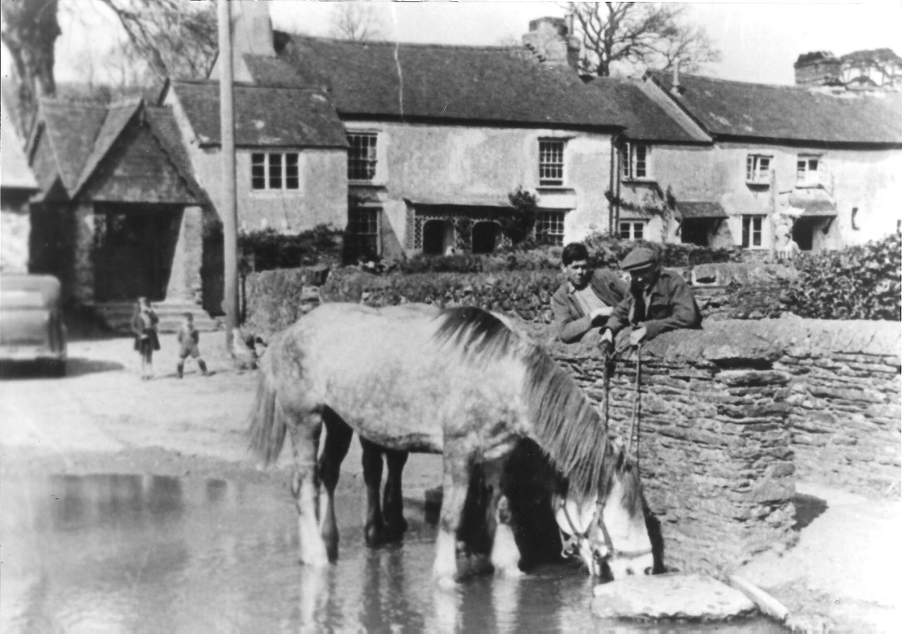
Another view of the Ford and Church Terrace
and the house to the left with its outbuildings was the site of Ford Farm (19). On the corner by the main road, the last house in the row known as Victoria Cottages is called The Old Post Office (20) and is one of several places in Harberton which have served this purpose over the years.
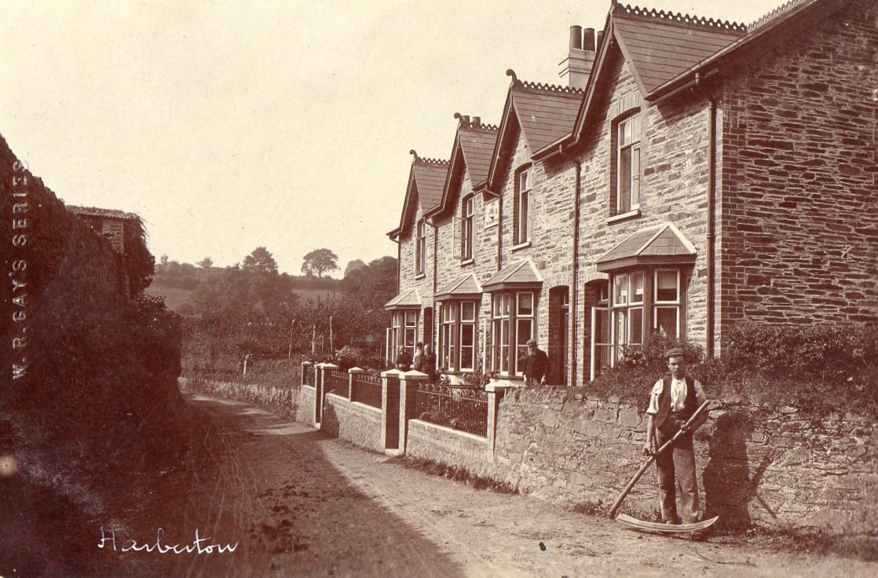
Victoria Cottages, with Post Office Corner on right hand side
Turning back along the road below the churchyard, on our left we pass Symonds Farm (21) now a private dwelling known as Harberton House, and barn.
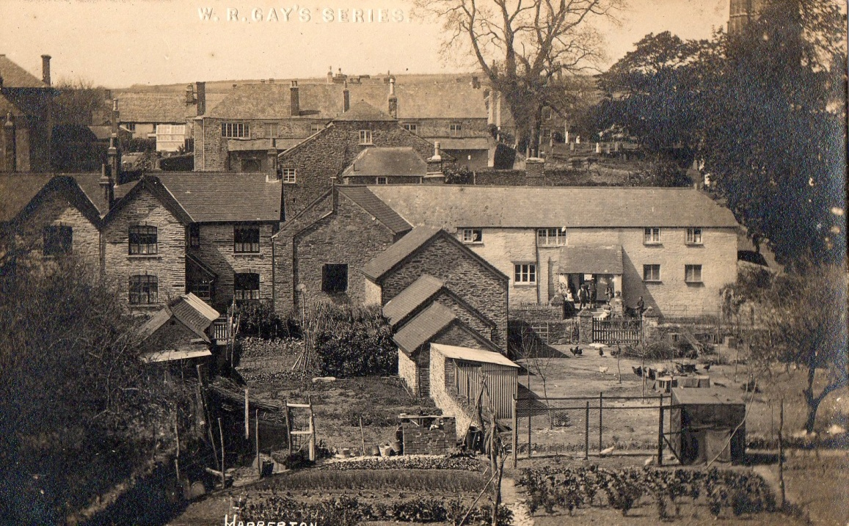
Symonds Farm is the house on the middle right of the picture
Further along the road we come to the

Simmonds Farm area
On the way up the slope on the right is The Tall House (22) which was also at one time the village post office. On the left at the top of the slope is Simmonds Farm (23) which was probably the home of some of the Varder family.
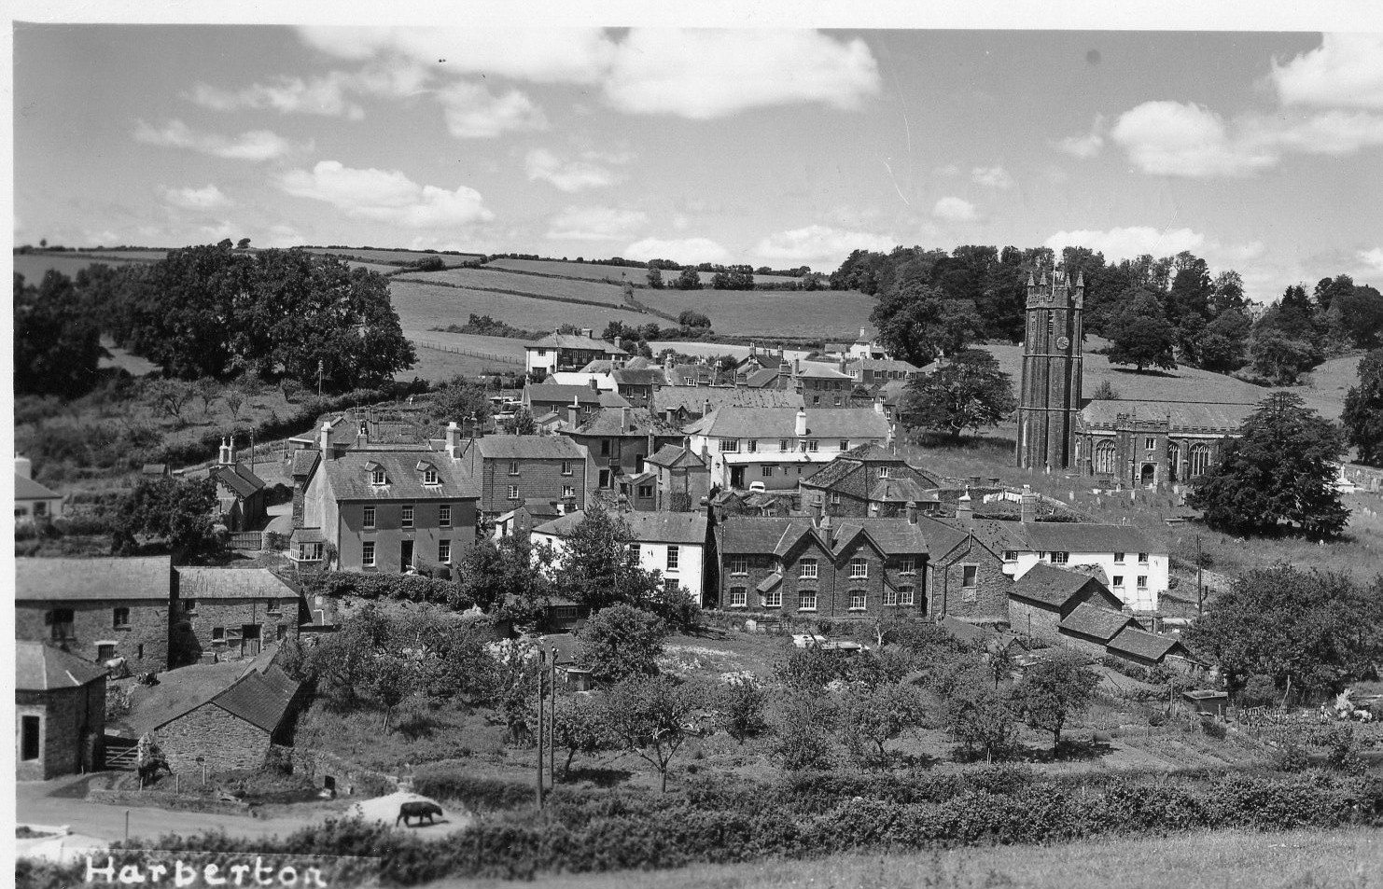
Simmonds Farm is the house in the middle left of the picture
Around the corner to the right are Old Hall Cottage and The Old Hall, which were the site of the Harberton Constitutional Institution and Reading Room (24)
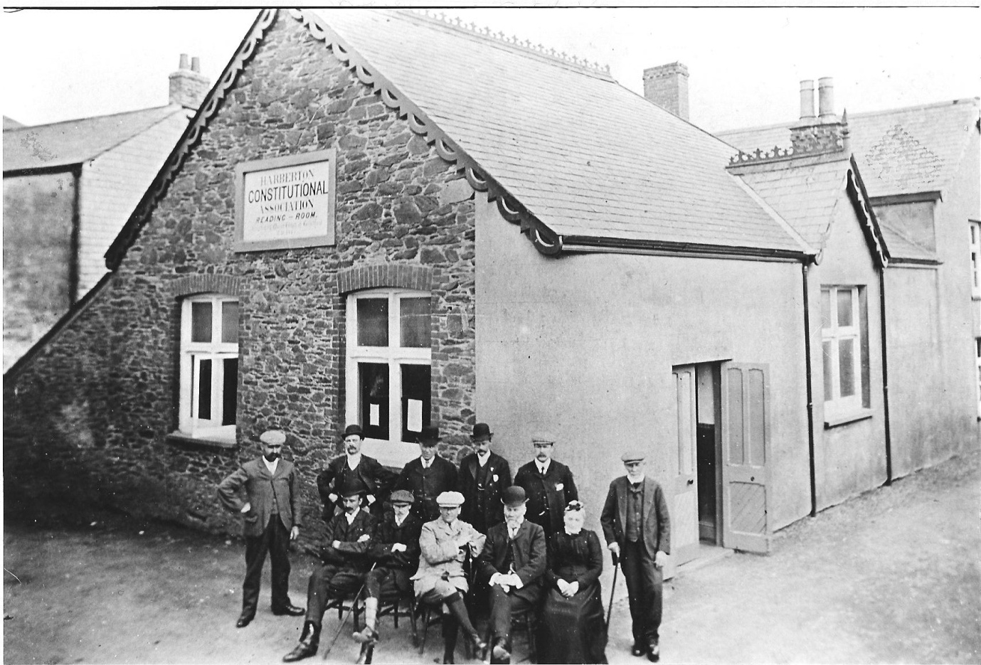
Harberton Constitutional Club and Reading Room
built by Major Trist in 1885, and the venue for many village meetings and entertainments from the late nineteenth to the mid twentieth century. From here we go down the hill on the left to the
Preston Farm area
At the bottom of the hill, on our left, is the site of the Globe Inn (25) converted into a private dwelling, initially called Marbeth but more recently reverting to the name Globe House.
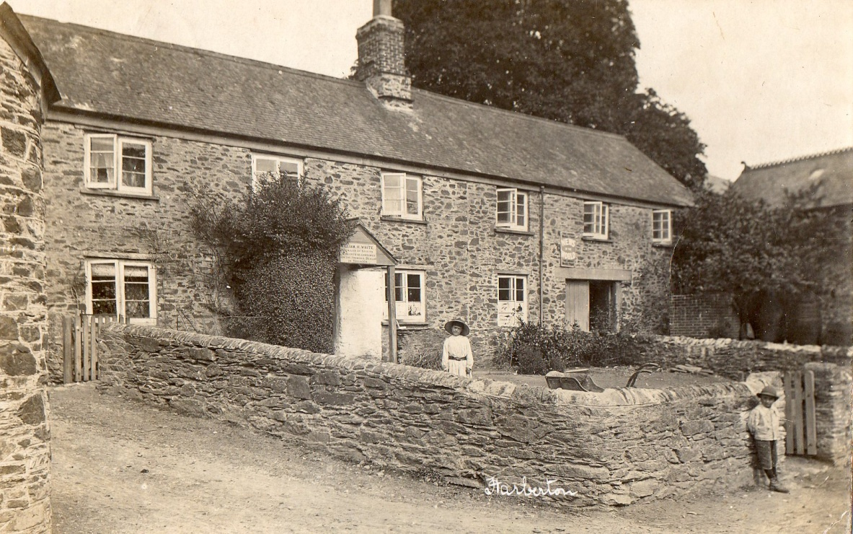
The Globe Inn
On the other side of the road is The Old Forge (26) which until 1977 recently served as a garage and petrol station before being converted to a private dwelling. In an earlier incarnation this was most probably where Stephen Varder had his workshop. We have a contemporary account of this from one of Mary Varder’s sons, describing a visit when the family briefly came back to England from Tierra del Fuego in 1879:
‘We went to grandfather’s home at Harberton, near Totnes, in Devonshire, where we met various uncles and aunts. I remember a great barn, cows, pigs, chickens, ducks, geese and turkeys; an orchard, a forge and a wheelwright’s shop with a circular saw driven by a water wheel. What an enchanting place we children thought it! One day we went to visit an aunt and some cousins at their farm some three miles from Totnes.’
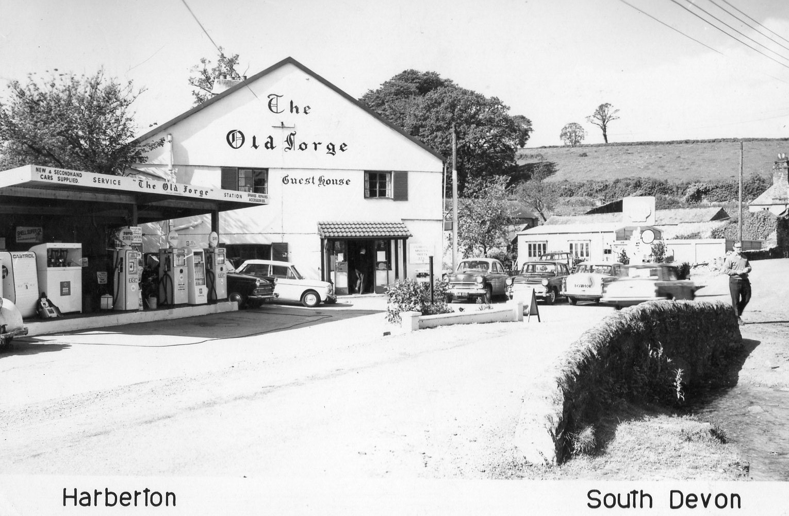
The Old Forge in its days as a garage
Travelling west from here we come to Preston Farm (27), one of the oldest farms in the village. On the corner of St. Andrew’s Cottages across the road, at ground level, is another Ordnance Survey benchmark (about 227 ft above sea level). On your right is the site of the Wesleyan Methodist Chapel (28).
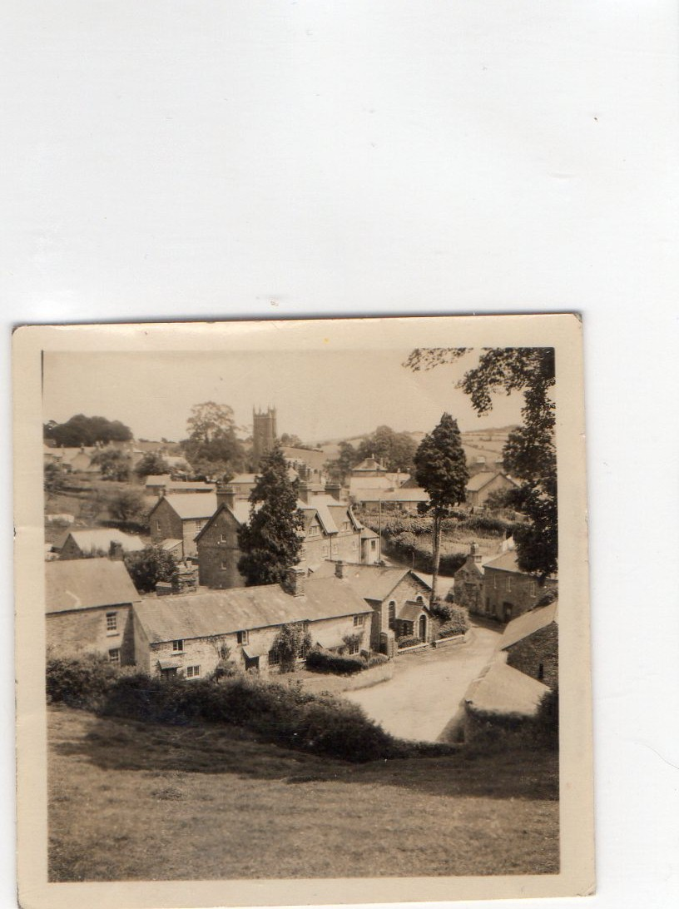
The Wesleyan Chapel is in the middle right of the picture
This was built about 1878, at a cost of £320 to accommodate 110 worshippers and was converted into a private dwelling, Wesley House, in 1974.
From here we proceed up the road towards Leigh Bridge until we reach the
Tristford Farm area
On our left is a lane which nowadays leads to the Harberton Cricket Club’s ground. In a Glebe Terrier dating from about 1680 this lane is referred to as The Windmill Way (29), and in the 1842 Tithe Apportionment there are three fields behind the cricket field called Windmill, Higher Windmill and Lower Windmill. Just up the lane on the right are two private houses which, in the early nineteenth century comprised Higher Vicarage Farm (30). Opposite the bottom of the lane is the site of Lower Vicarage Farm (31) which was a seventeenth century farm, substantially remodelled around 1860 when it was given its present name of Tristford Farm. Slightly further up the hill on the left is the site of The Old Vicarage (32) nowadays referred to (with no justification) as The Manor.
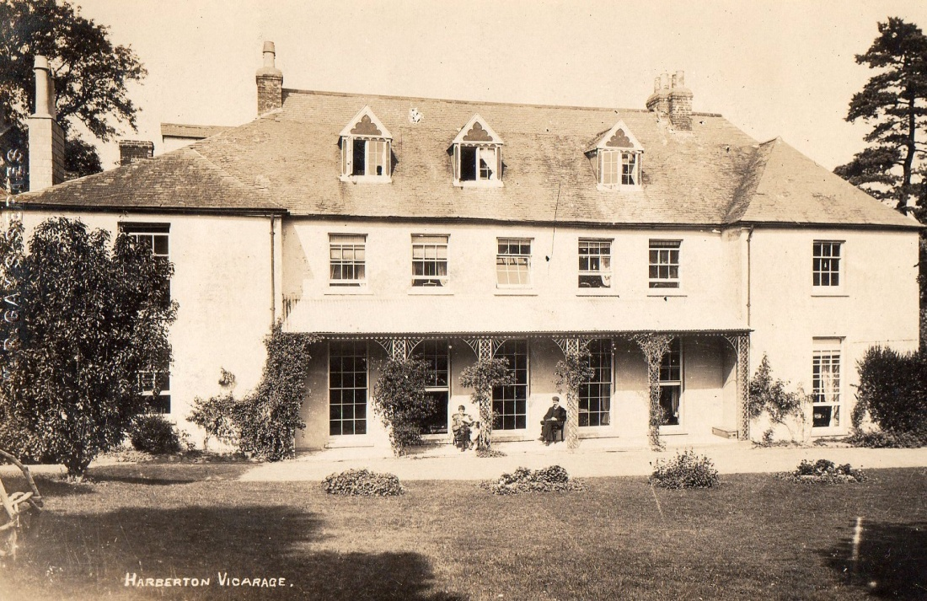
The Old Vicarage, Harberton
The new vicarage, on the road out of the village towards Tristford house was built as a replacement in 1953/4. Returning to the site of the Wesleyan Chapel at the bottom of the hill we take the turning to the left to the
Back Road area
The first set of houses on the left is St Clement’s Terrace (33), one of many ’improvements’ made in Harberton in the early twentieth century by Robert Harvey, in this case built in 1904 to replace a row of old thatched cottages, colloquially referred to as ‘Fleas Alley. Just above the terrace, on the same side of the road is Town Farm (34), again built by Robert Harvey as part of his campaign of village improvement. When we reach the road junction further up the hill we see, on our left, the site of the Harberton Constitutional Association and Club (35), yet another of Robert Harvey’s gifts to the village, built in 1923 and closed for conversion into three dwellings in the early 1990s.
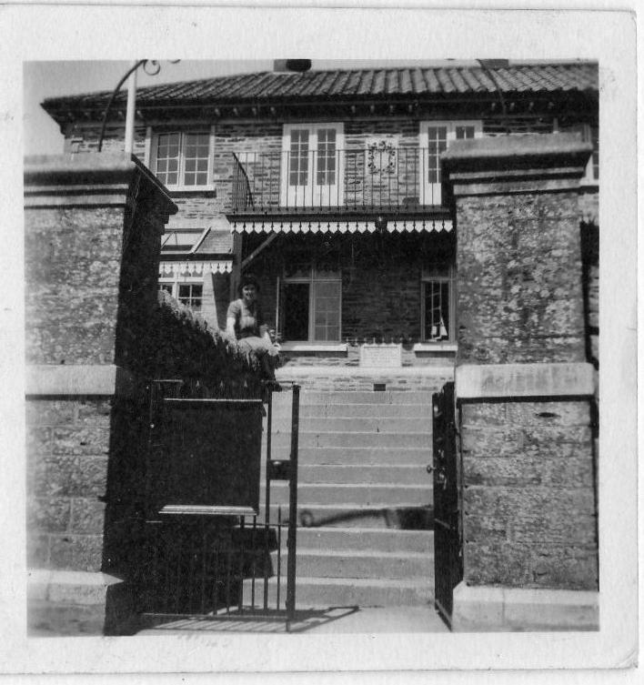
The Harberton Constitutional Association and Club
The playing field behind this building was also given to the village by Samuel Harvey, Robert’s son, with a condition that it was granted for as long as there was a monarch on the throne of England.
Opposite the old club is Tillyland (36), shown as the village Post Office on the map of 1904.
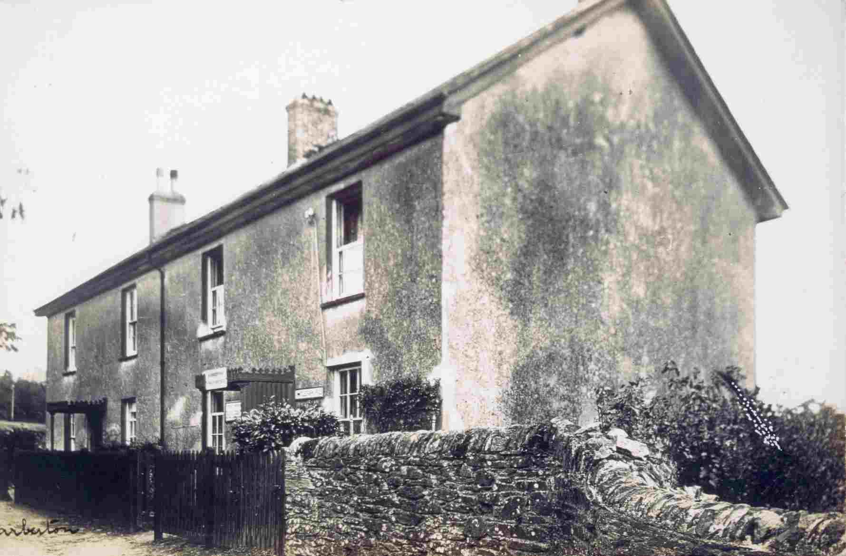
Tillyland with the post office sign above the door
We now turn right into the
Tristford Road area
Substantial rebuilding must have taken place around this area of the village in the mid-eighteenth century. On our left we can see Virginia Cottage (37), with a date plaque for 1753, and on our right Vine House (38), with a date plaque for 1764.
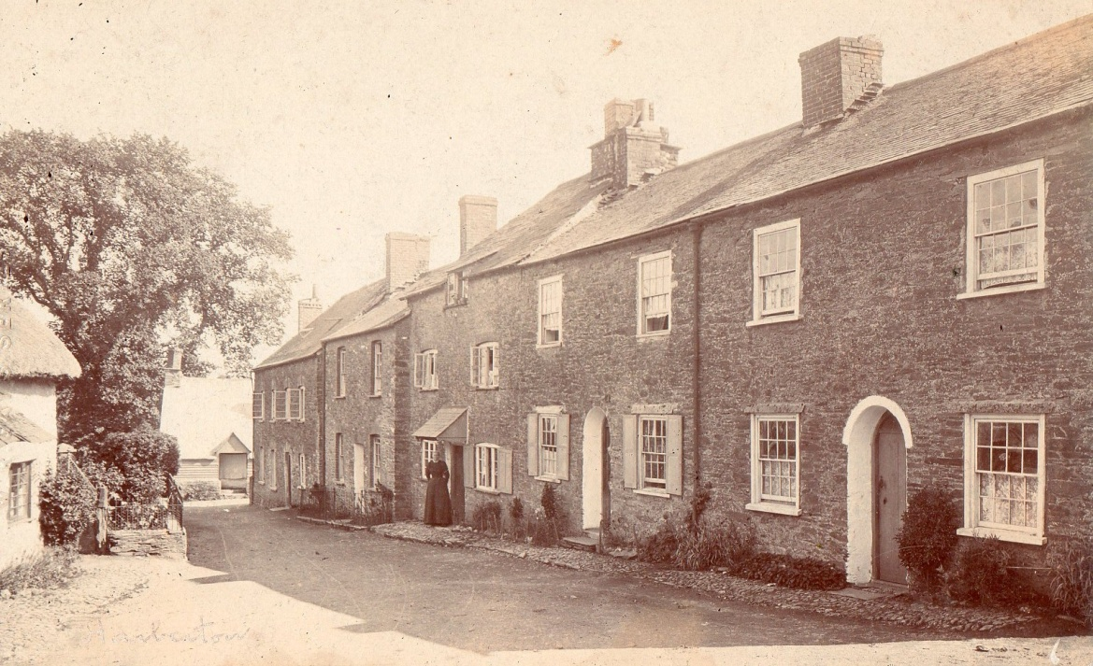
Tristford Road, with Vine House at the bottom, above the Almshouses
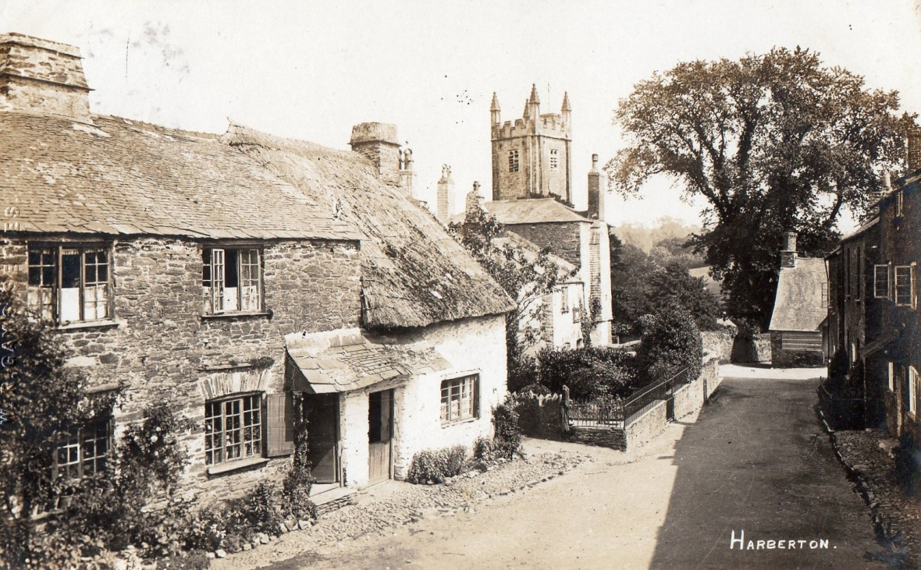
Tristford Road, with the School House partially obscuring the church tower
The building below Virginia Cottage is the School House (39), which was probably originally both the schoolmaster’s house and the school room, with a date plaque for 1751. Just down the cul de sac on the left is the site of the Village School (40) yet another conversion to a private dwelling, Chancery Cottage, after it was closed as unsafe in 1961. The school was rebuilt in 1872, and enlarged in 1883, at which time it was expected to handle 130 pupils.
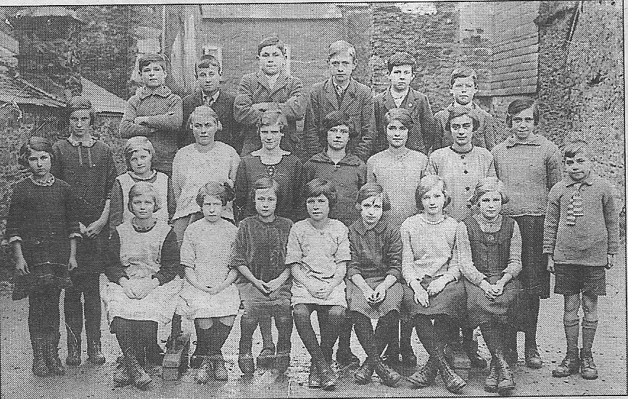
Children from Harberton School in the 1920s
To the left of the churchyard gate is the site of the Almshouses (41) demolished in the 1970s and replaced by another private dwelling called Wyse House. This name commemorates Henry Wyse, who in 1680 left enough money to build ‘ten small rooms for as many poor people.’
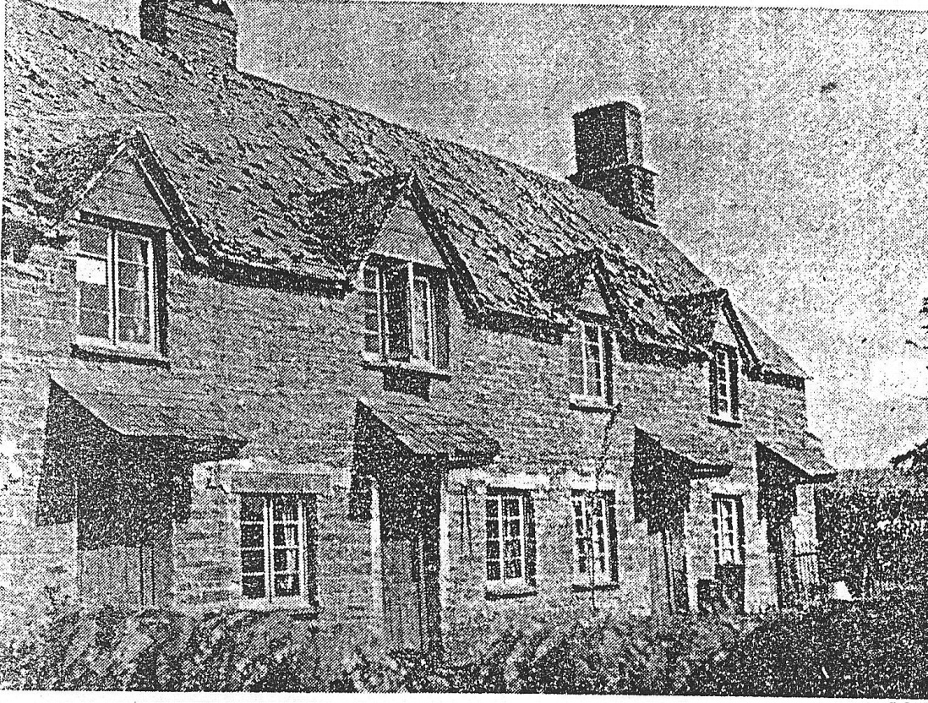
Harberton Almshouses
Behind Vine House, down a small private lane can be found St. Andrew’s Well (42), which until the 1960s was still used to provide water for baptisms in the church. Finally we return to the
Village Square
Here we find the Church House Inn (43), of uncertain date, the present building being mid to late sixteenth century, although it is possible that it replaced something contemporary with the building of the church in late thirteenth and early fourteenth centuries.
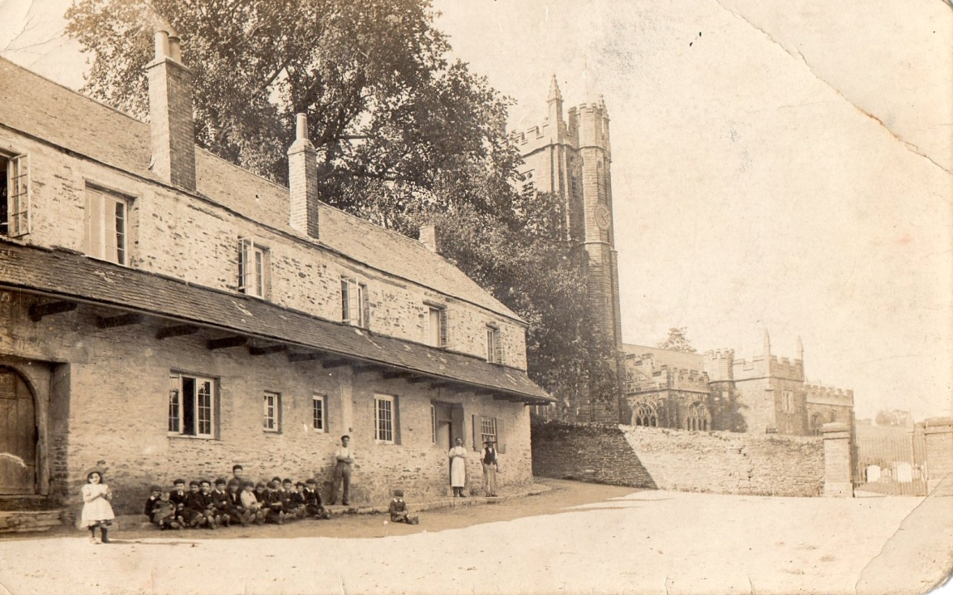
Harberton Village Square with the Church House Inn and the church gateway
Across the square from the Church House is a small house called Church Cottage (44)
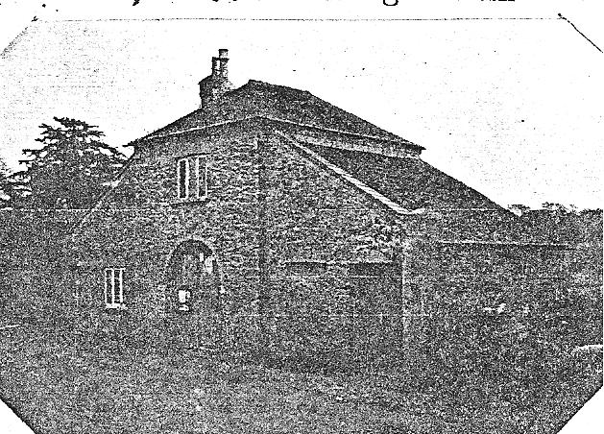
Church Cottage in its days as a coach house
at one time a coach house, but in more recent years a private dwelling – except that it has not been lived in for some 35 years and was the subject of much media coverage recently (2011) when an attempt was made by a squatter to redress the situation. Church Court, on the edge of the square in Fore Street, is a modern replacement for the older houses in Fore Street and Garden Terrace which were demolished in the mid nineteen seventies. In Fore Street (45) were the village baker, on our right in what is now Harbourne House, and the village shop in the houses on the other side of the road.
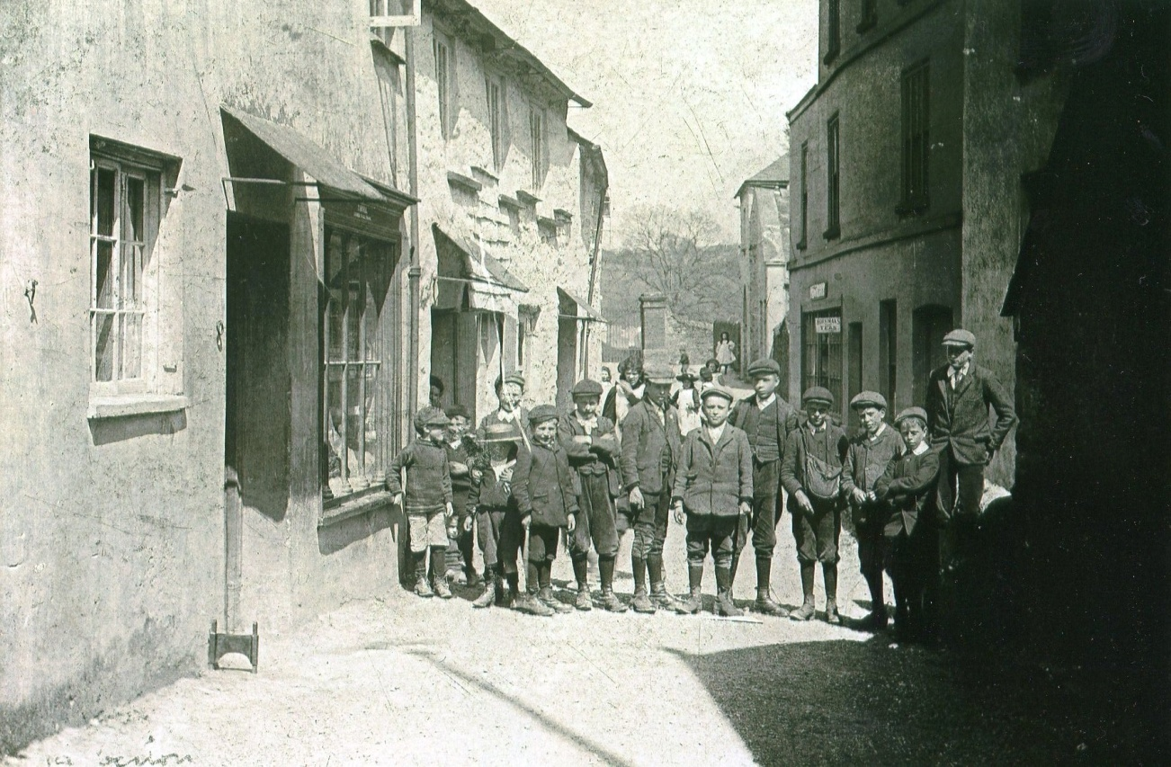
A view of Fore Street with the baker’s shop on the right and the village shop on the left
As we now return through the churchyard gate this completes our tour of the centre of the village. Many of the changes in the village over the years have been influenced by the families in the ‘big’ houses in the wider parish, such as Dundridge, Great Englebourne, Sandwell and Tristford, and hopefully these will be the subject of later presentations.
If you are interested in pictures of the village as it was, then you can visit the village website, run by John Culf at www.harbertondevon.co.uk and follow the links to Picture Galleries and then to Old Harberton Walkabout for a wider selection of postcards and photographs of Harberton.
We are always on the lookout for more postcards and photographs to fill in currents gaps in the coverage (for example we have no picture of the school building) and would appreciate any offerings of pictures to copy for the village archive. You can contact me at Chancery Cottage, or ring me on 01803 864654, or email me at stanleyoldfield@googlemail.com if you think you have anything of interest.
A footnote:
Acreages of farms around the village centre at the time of the Tithe Apportionment in 1842
Simmonds and Guests 29 Symonds 36 Preston 69 Harberton Town 21 Higher Vicarage 61 Lower Vicarage 124 Great Ford Barn 54 Little Ford Farm 39

